**Magnetism of O and B type star notes**

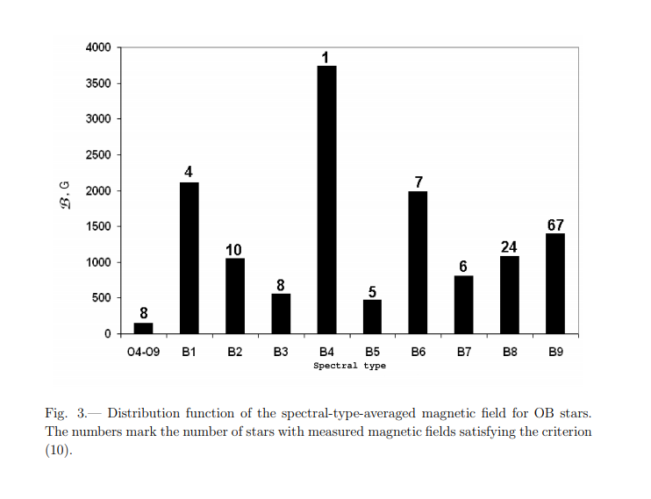

[1]

[1]

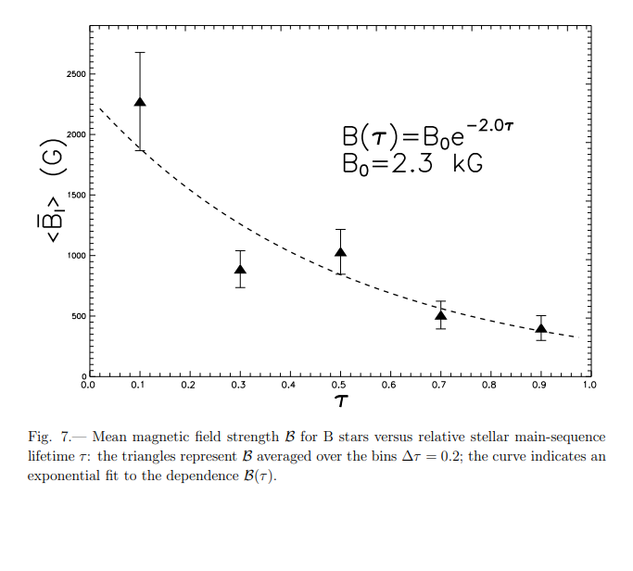

Fossil origin hypothesis [1]

* “Suggests that the stellar magnetic field of OBA stars at the present epoch is a fossil remnant of the magnetic field of the molecular cloud in which the star was formed” (Kholtygin et al., 2010)
* No correlation between mean magnetic field strength and projected rotational velocity of OB stars, consistent with the fossil origin hypothesis
* Over the main sequence lifetime of a B type star, its mean magnetic field strength can decrease by a factor of 5-7 (fig 7)

[2]

* Structurally simpler in high mass, hotter stars than in small cooler stars
* Frequently much stronger than the fields of cool stars
* They show stability of their large scale and smaller-scale structures on timescales of decades
* Characteristics show no clear correlation with stellar properties like age, mass or rotational velocity
* MiMeS project ~ 550 stars observed with approximately 65 stars showing evidence for magnetic fields and 30 of those 65 being identified as magnetic stars
* Of the approx. 90 O type stars in the sample previously unknown to host magnetic fields, 6 are found to be magnetic for an incidence of 7+-3%
* Of the approx. 430 B type stars in the sample previously unknown to host magnetic fields, 32 are found to be magnetic for an incidence of 7+-1%.
* The magnetic stars exhibit periodically variable longitudinal fields which corresponds to magnetic fields with dipole components.
* The strengths of these fields can range form several hundred gauss to tens of thousands of gauss
* General magnetic characteristics of B and O type stars are very similar

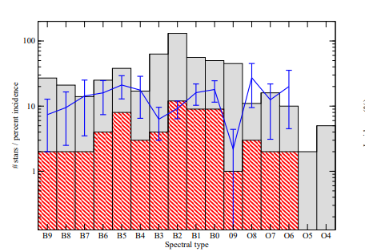

Figure 1: magnetic incidence as a function of spectral type

[3]

* A fraction between 5-10% of MS stars with radiative envelopes host detectable fields, regardless of spectral type according to Magnetism in Massive stars (MiMeS) and B fields in OB stars (BOB).
* Detection relies on the Zeeman effect (the splitting and polarisation of spectral lines produced by a B field)
* The topologies of magnetic massive stars are usually similar to those of Ap stars, oblique dipole and very stable over years
* Ap stars possess strong large-scaled organized B fields, all Ap stars are magnetic, observed field is always higher than 100 G for the longitudinal field (corresponds to a polar field of about 300 G)
* B fields of the order of kilogauss are considered strong fields, whereas fields n the order of hundred Gauss are considered weak fields
* The sun has an average B field strength of 1G, but sunspot areas can reach up to 3000G.
* Massive stars have a thin sun-surface convective layer; therefore, it is plausible that a dynamo process could operate in this zone. It is also plausible that this convective layer could reach the surface of the star
* It has been shown that increasing B-field strengths are found in increasing masses and towards the end of the MS [4]

[4]

* The iron convective zone (FeCZ) in O and B type stars contain very little mass due to low densities in the outer layers of the star.
* The transport of energy in the FeCZ by convective motions is inefficient, so radiative energy transport dominates and transports most of the total flux.
* This is due to the low density and convection being significantly super adiabatic.
* Convection zones close to the stellar surface of hot massive stars could lead to B fields being readily produced by dynamo action and reach the stellar surface via magnetic buoyancy, i.e. potential sunspots
* The FeCZ is a turbulent layer close to the stellar surface and as such could be a site of a small-scale dynamo ( small scale dynamos result in B-fields with correlation scale of order or smaller than the forcing scale)
* MS massive stars usually rotate rapidly, typical velocity of 150 km s-1, which could give B-fields up to 2kG which is supported by simulations of turbulent convection in the presence of rotation and shear
* Hence dynamo action in the FeCZ could depend on the stellar rotation and the shear profile, whilst the scale of the B-field is dependant on the type of dynamo action occurring.
* The dynamo could also be affected by a large-scale B-field penetrating upwards from the radiative zone below the FeCZ.
* 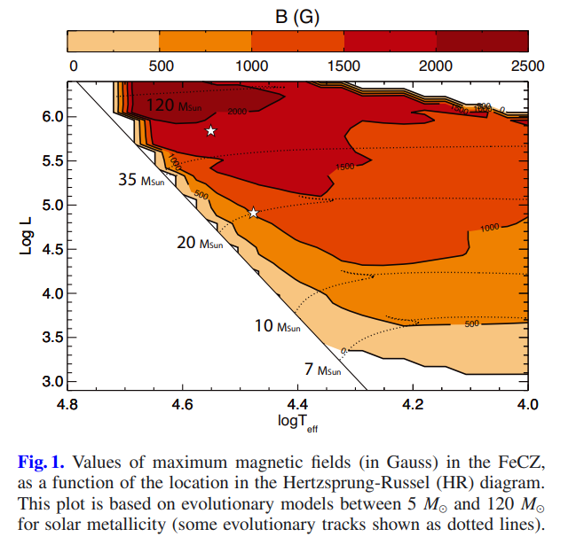[4] 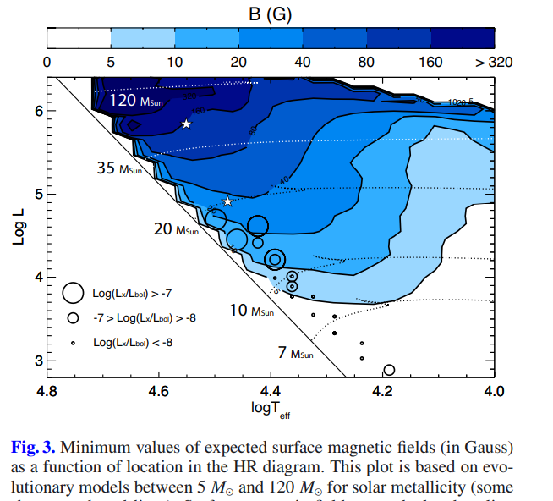

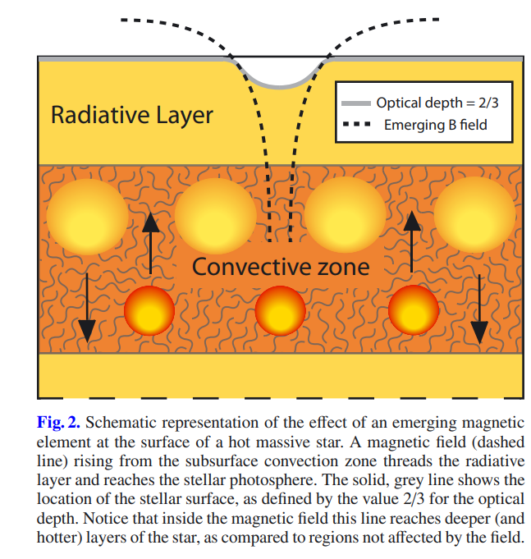

[1] Kholtygin, A., Fabrika, S., Drake, N., Bychkov, V., Bychkova, L., Chountonov, G., Burlakova, T. and Valyavin, G., 2010. Statistics of magnetic fields for OB stars. *Astronomy* Letters, [online] 36(5), pp.370-379. Available at: <https://arxiv.org/pdf/1005.3705.pdf> [Accessed 20 February 2021].

[2] Wade, G. A., Grunhut, J., Alecian, E., Neiner, C., Aurière, M., Bohlender, D. A., David-Uraz, A., Folsom, C., Henrichs, H. F., Kochukhov, O., Mathis, S., Owocki, S. and Petit, V. (2013) “The magnetic characteristics of Galactic OB stars from the MiMeS survey of magnetism in massive stars,” Proceedings of the International Astronomical Union. Cambridge University Press, 9(S302), pp. 265–269. doi: 10.1017/S1743921314002233.

[3] Briquet, M., 2015. Magnetic fields in O-, B-and A-type stars on the main sequence. In *EPJ Web of Conferences* (Vol. 101, p. 05001). EDP Sciences.

[4] Cantiello, M. and Braithwaite, J., 2011. Magnetic spots on hot massive stars. *Astronomy & Astrophysics*, *534*, p.A140.